⚙️ AI Ad Agent Setup Guide (n8n Workflow)
This guide turns your laptop into a fully automated cinematic ad factory — powered by GPT, Veo3, Shotstack, and Google Sheets — with no editing or skills required.

🔧 STEP 0: Set Up n8n
Your automation brain. You can run n8n in two ways:

🔹 Use n8n.cloud (Easiest, Paid)
- Go to https://n8n.cloud
- Sign up and start your free trial or paid plan
- Once logged in, go to Workflows → Click “New”
- You now have a cloud-hosted automation system

🔹 Import JSON.file (n8n workflow) for AI Ad Agent

🔹 Download the JSON File
You should have received a file like:
AI_Ad_Agent.json
→ Save it to your desktop or workspace folder.

🔹 5.2 Upload the JSON into n8n

If you're using n8n.cloud:
- Log into your account: https://n8n.cloud
- In the sidebar, click Workflows
- Click the “Import” button at the top right
- Choose “Import from File”
- Select your downloaded AI_Ad_Agent.json
- n8n will load the full visual workflow

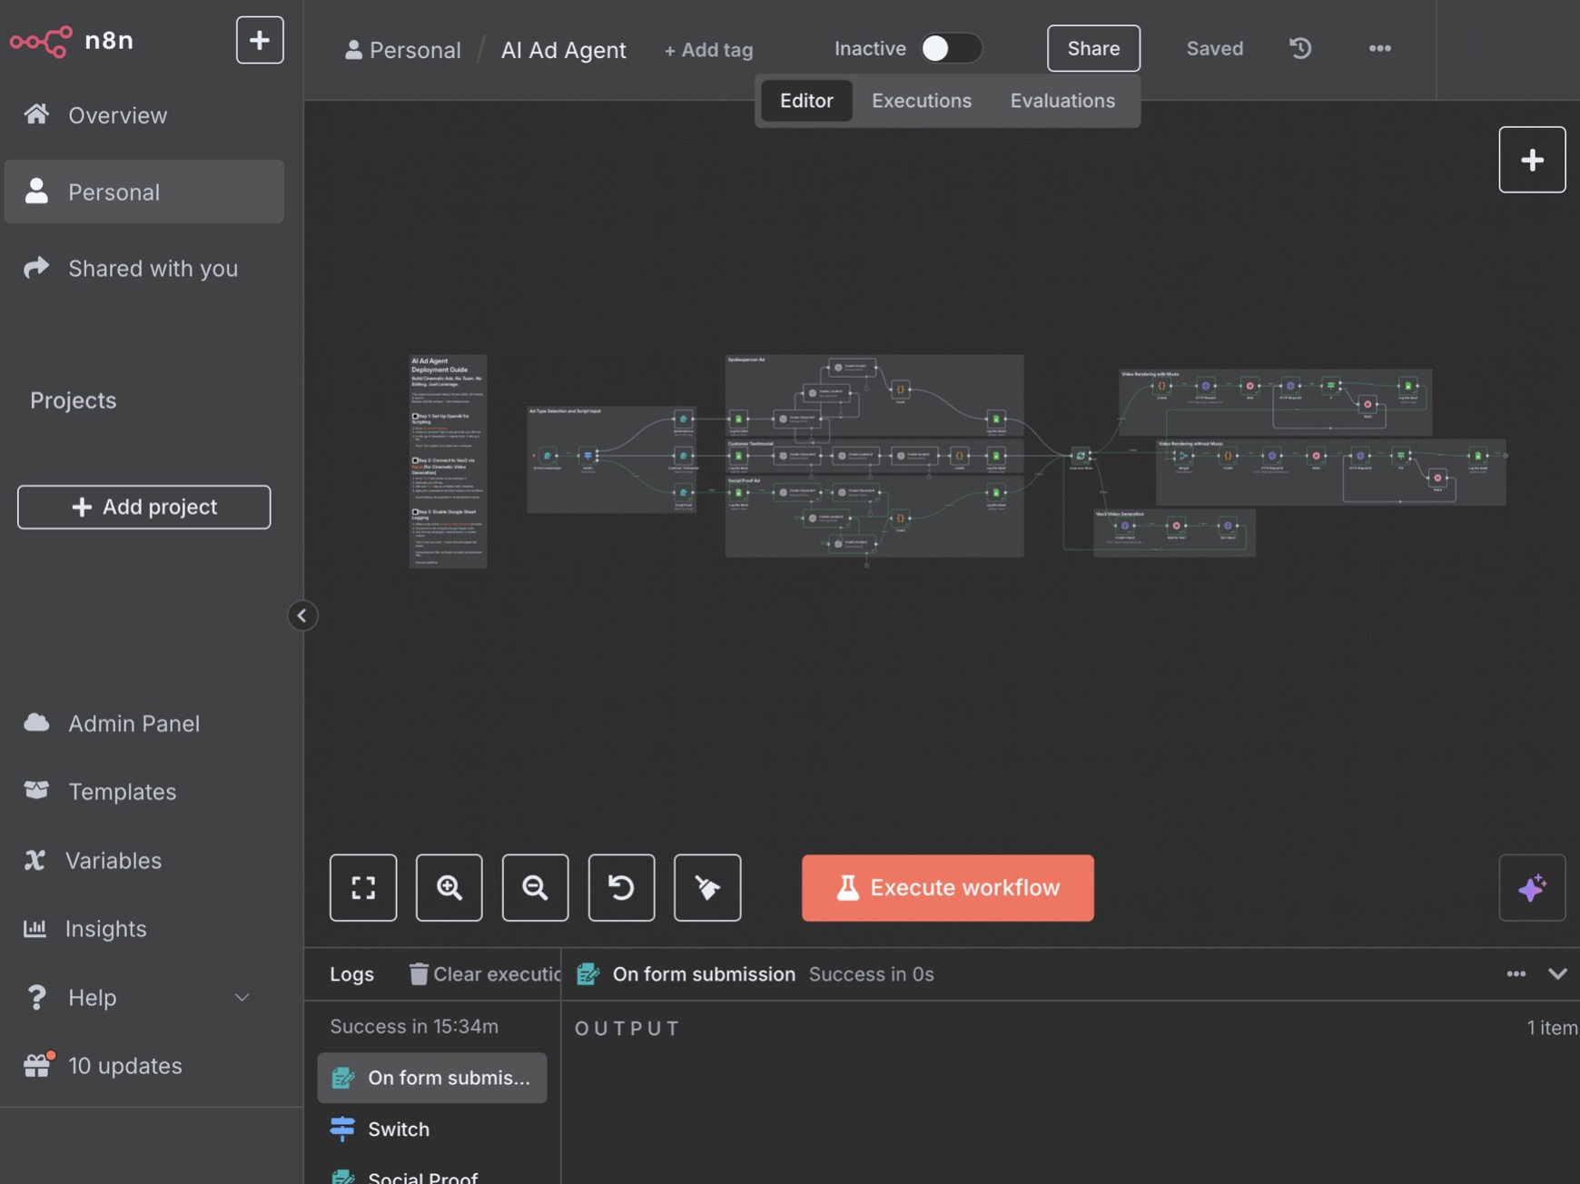
✅ After setup, you're ready to build and connect your AI Agent system.

🔳 Step 1: Connect OpenAI (for Scriptwriting)
This powers the system's logic, persona generation, script segmentation, etc.

1.1 Get Your OpenAI API Key
- Go to: https://platform.openai.com/api-keys
- Log in or sign up
- Click "Create new secret key"
- Copy the key (starts with sk-...) and store it somewhere safe

1.2 Add OpenAI to n8n
- Open your n8n dashboard
- Go to Credentials → Click “New Credential”
- Select OpenAI Chat
- Paste your API Key into the field
- Give it a name (e.g., OpenAI - AI Equity)
- Click Save

1.3 Link Credential to GPT Nodes
- In the workflow, find the nodes like Create Character(1-4), Create Location(1-3), Create Scripts(1-3), etc.
- Open the node → Go to the "Credentials" section
- Choose the OpenAI credential you just created
- Click Save
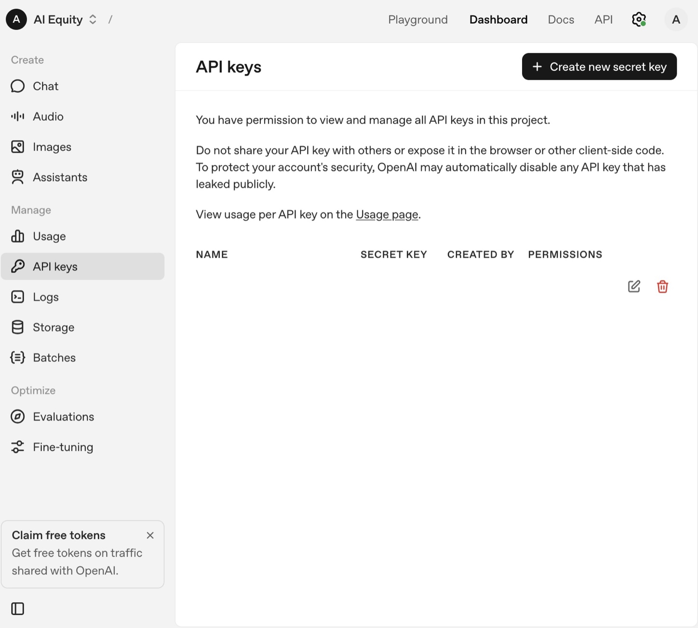
✅ Done: You’ve now enabled GPT to write scripts, characters, and breakdowns.

🔳 Step 2: Connect Veo3 via Fal.ai (for Cinematic Video Generation)
This creates the actual videos using Veo3 through Fal.ai’s API.

2.1 Create Fal.ai Account
- Go to: https://fal.ai
- Sign up with Google or email
- Once inside, go to: https://fal.ai/profile
- Scroll to “API Keys”
- Click “Generate Key” → Name it something like n8n-agent
- Copy the key (starts with fal-...)

2.2 Add Fal.ai Credential in n8n
- In n8n, go to Credentials → Click “New Credential”
- Choose HTTP Header Auth
- Set:
  - Name: Fal.ai - Veo3
  - Header Name: Authorization
  - Value: Bearer YOUR_FAL_API_KEY (paste the full key with the word Bearer in front)
- Click Save

2.3 Apply Fal.ai Credential to HTTP Nodes
- In the workflow, locate the nodes that send prompts to Veo3 via HTTP (called Create Video 1, etc.)
- Open the node → Scroll to Authentication
- Choose “Header Auth”
- Select Fal.ai - Veo3
- Click Save
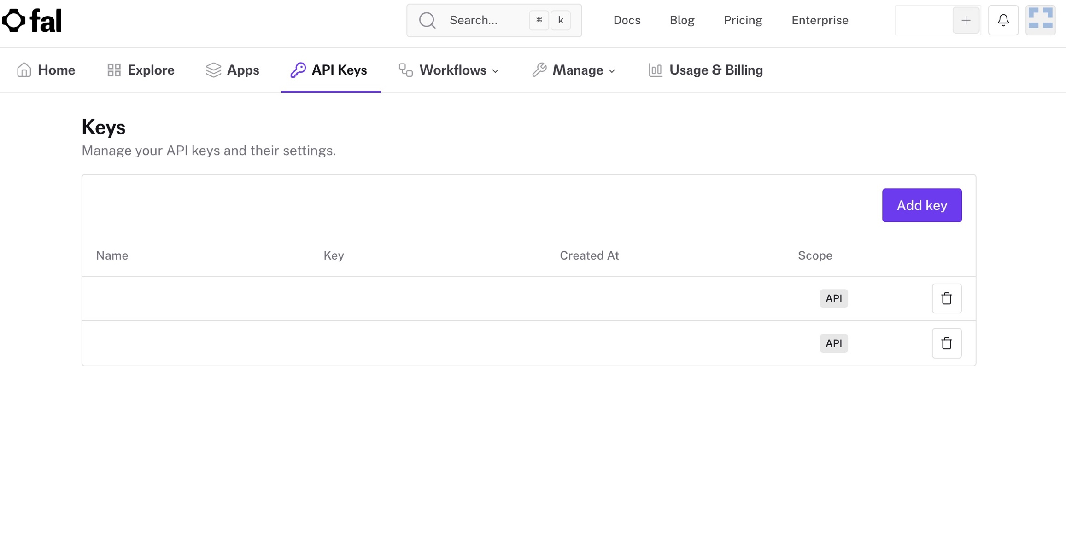
✅ Done: You’ve now linked cinematic video generation to the system. No manual prompting.

🔳 Step 3: Enable Google Sheets Logging
This stores campaign results, scripts, and prompts in a log format — ideal for managing client outputs or reviewing performance.

3.1 Copy the Template Sheet
- Open this link:
👉 AI Equity Google Sheets Template
- Go to File → Make a copy
- Rename it as you like (e.g., Ad Agent Log)

3.2 Set Up Google Sheets Access in n8n
First-time only setup:

a) Create a Google Cloud Project
- Go to: https://console.cloud.google.com/
- Click "Select a Project" → New Project
- Name it something like n8n-sheets-access
- Click Create

b) Enable Sheets API
- In the left nav, go to APIs & Services → Library
- Search: Google Sheets API
- Click it → Click Enable

c) Create OAuth Credentials
- Go to: APIs & Services → Credentials
- Click “Create Credentials” → OAuth client ID
- Choose Web Application
- Add this to “Authorized redirect URIs”:
https://api.n8n.cloud/oauth2-credential/callback
- Click Create
- Copy the Client ID and Client Secret

d) Add to n8n
- In n8n: Go to Credentials → New Credential → Google Sheets OAuth2
- Paste in the Client ID and Client Secret
- Name it Google Sheets - Ad Logs
- Click Connect OAuth Account
- Sign in with your Google account
- Click Allow
- Save

3.3 Connect Sheet in Workflow
- Open the Google Sheets node in the workflow
- Under Authentication, choose Google Sheets - Ad Logs
- Under Spreadsheet ID, paste the ID from your copied sheet (e.g. from the URL: docs.google.com/spreadsheets/d/**SPREADSHEET_ID**/edit)
- Choose the correct Sheet Name (usually Sheet1)
- Map the appropriate columns (e.g., Script, Character, Prompt, etc.)
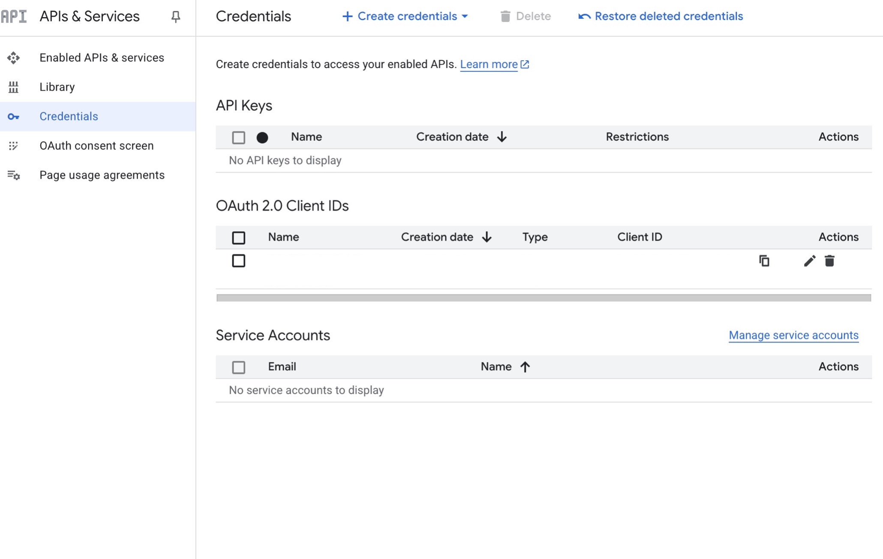
✅ Done: Your system now logs each campaign output to Google Sheets.

🎵 STEP 4: Add Shotstack (for Music + Rendering)
This is used to add background music and final video stitching if needed.

4.1 Create a Shotstack Account
- Go to https://shotstack.io
- Create account → Go to your Dashboard
- Copy your API key (sandbox or production)

4.2 Add to n8n
- Go to Credentials → New Credential → HTTP Header Auth
- Name: Shotstack
- Header Name: x-api-key
- Value: YOUR_API_KEY
- Save

4.3 Use in Workflow (Optional Node)
- Find SHTTP Request and HTTP Request3 nodes (Shotstack Render)
- Assign the Shotstack credential
- In the JSON payload, define:
  - Input video (from Veo3)
  - Output config (e.g., resolution, duration)

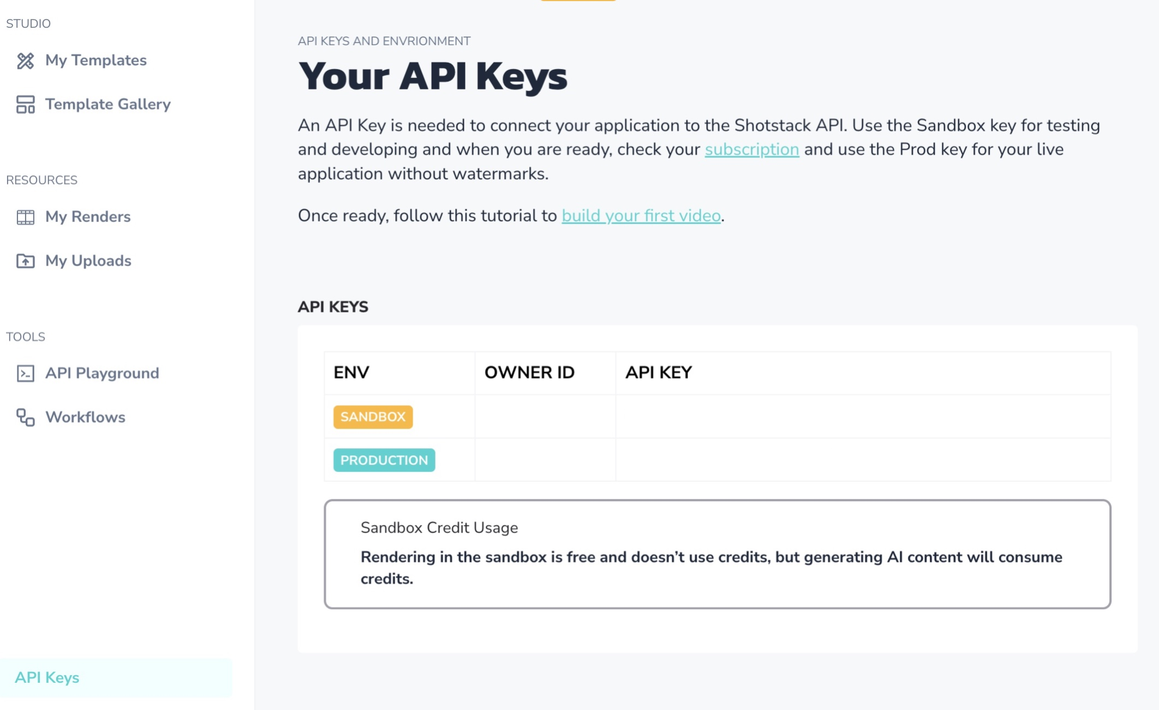

✅ Shotstack adds polish to the video — optional for MVP, recommended for music.

✅ Final Workflow Components
Once the credentials are set up, plug them into the matching nodes:
Node Type | Use | Credential
ChatGPT Nodes | Scriptwriting, breakdown, persona creation | OpenAI
HTTP Veo3 Nodes | Video generation via Fal.ai | Fal.ai - Veo3
Google Sheets | Log outputs to spreadsheet | Google Sheets OAuth
Shotstack | Background music, stitching | Shotstack

✅ System Ready

✅ Support
If you have any technical issues with the set-up, please contact our support:
aiequity.system@gmail.com

